CURTIN ISAD 3000 · PROJECT PORTAL
User Guide
Curtin ISAD 3000 Project Portal
Project | Curtin ISAD 3000 Project Portal
Document ID | CP-UG-001
Version | 5.0
Date | 25 October 2026
Author | Darren
Status | Draft for review
Classification | Internal

A short, picture-based guide to the Curtin ISAD 3000 Project Portal: sign in, find a capstone project with search and filters, and read project details.

Document Control

Document information
Document title | User Guide
Document ID | CP-UG-001
Project | Curtin ISAD 3000 Project Portal
Document type | Short illustrated user guide
Version | 5.0
Author | Darren
Date issued | 25 October 2026
Status | Draft for review
Classification | Internal
Intended audience | Students and lecturers who use the Portal

Revision history
Version | Date | Author | Description of change
1.0 | 21 October 2026 | Darren | First full-length version.
2.0 | 21 October 2026 | Darren | Shortened and rebuilt with screenshots of the Portal.
3.0 | 23 October 2026 | Darren | Added Lessons & Videos and the maintenance notice.
4.0 | 23 October 2026 | Darren | Lecturer-managed lessons (add and delete), updated screenshots.
5.0 | 25 October 2026 | Darren | New Sign in / Create account tabs; role comes from your account.

Review and approval
Role | Name | Signature | Date
Author | Darren |  | 25 October 2026
Reviewer
Approver

Related documents
Document ID | Title
CP-SRS-001 | Software Requirements Specification
CP-UAT-001 | User Acceptance Testing (UAT) Document
CP-UG-001 (this document) | User Guide
CP-LG-001 | Login Guide

1. Open the Portal
The Portal lists 2,500 capstone project ideas that you can search, filter and read in detail.
Portal address: https://capstone-portal-test.tranphucdang0709.workers.dev/
TIP
You need a web browser and an approved email address you can open. There is no password: the Portal emails you a 6-digit code each time you sign in.

2. Sign in
- Open the Portal address. You land on the sign-in page.
- New here? Click Create account (see 2a below). Already registered? Stay on Sign in.
- Type your email and select Email me a code.
- Open the email "Your Capstone Portal sign-in code" and type the 6 digits. You are signed in automatically.
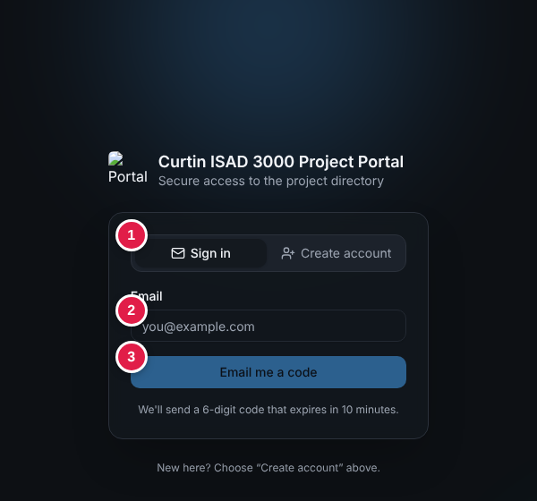
Sign-in page: (1) Sign in / Create account tabs, (2) email box, (3) "Email me a code"
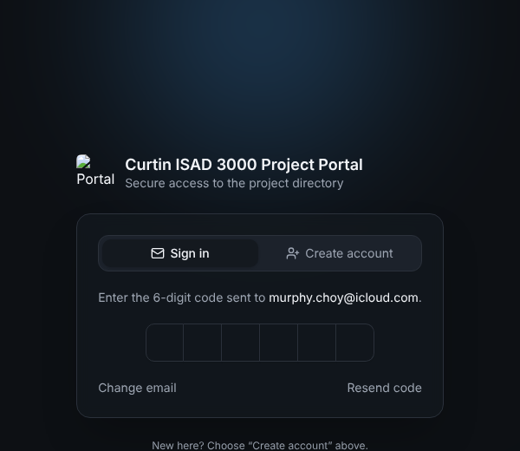
Code step: type the six digits from your email

2a. Create an account (first time only)
- Click the Create account tab.
- Type your name (optional) and your email.
- Under Account type keep Student. Choose Lecturer only if you are a lecturer - it works only for emails the portal owner has approved; otherwise your account is created as a student.
- Click Email me a code to create my account, then type the 6-digit code. You see "Account created. Welcome!" and you are signed in.
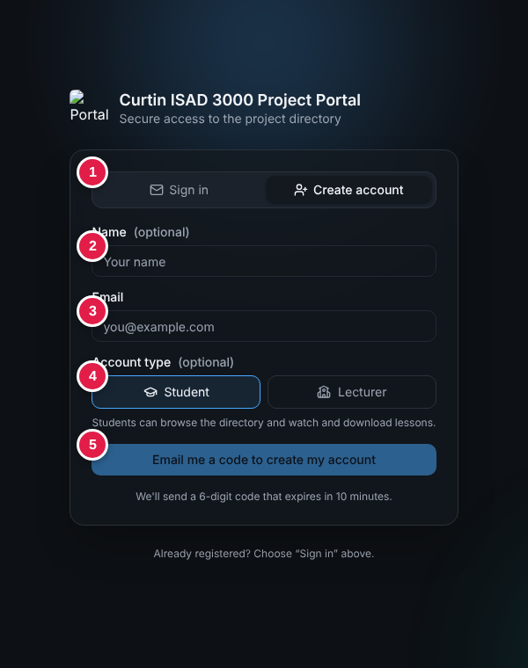
Create account: (1) tabs, (2) name, (3) email, (4) account type, (5) button
After that, always use the Sign in tab. Your role (Student or Lecturer) belongs to your account.
Need more detail or having trouble? See the Login Guide (CP-LG-001).

3. The Project Directory
After sign-in you see the directory. The numbers match the table.
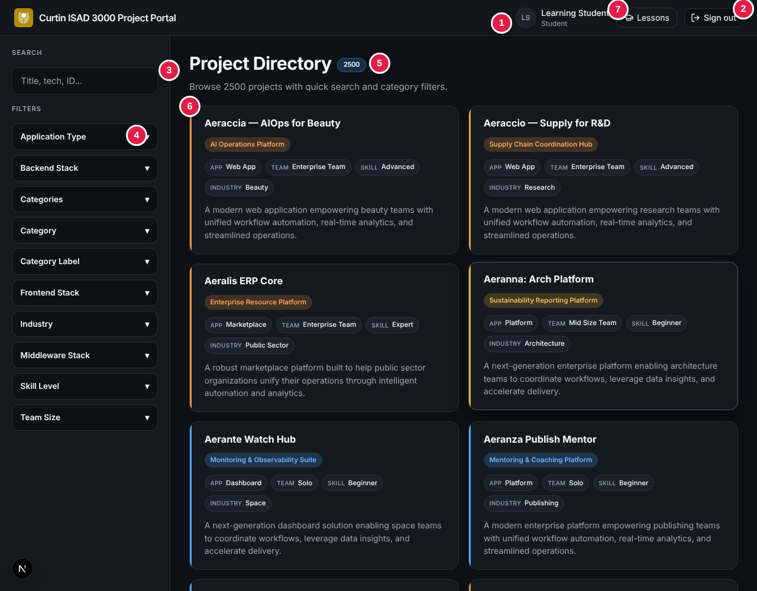
Project Directory (student view)
No. | What it is
1 | Your initials, name and role (Student or Lecturer).
2 | Sign out - ends your session.
3 | Search box - type to find projects.
4 | Filters - click a group name to open it.
5 | Total number of projects (2500).
6 | A project card: title, category, App / Team / Skill / Industry labels and a short description. Click it to open.

4. Search
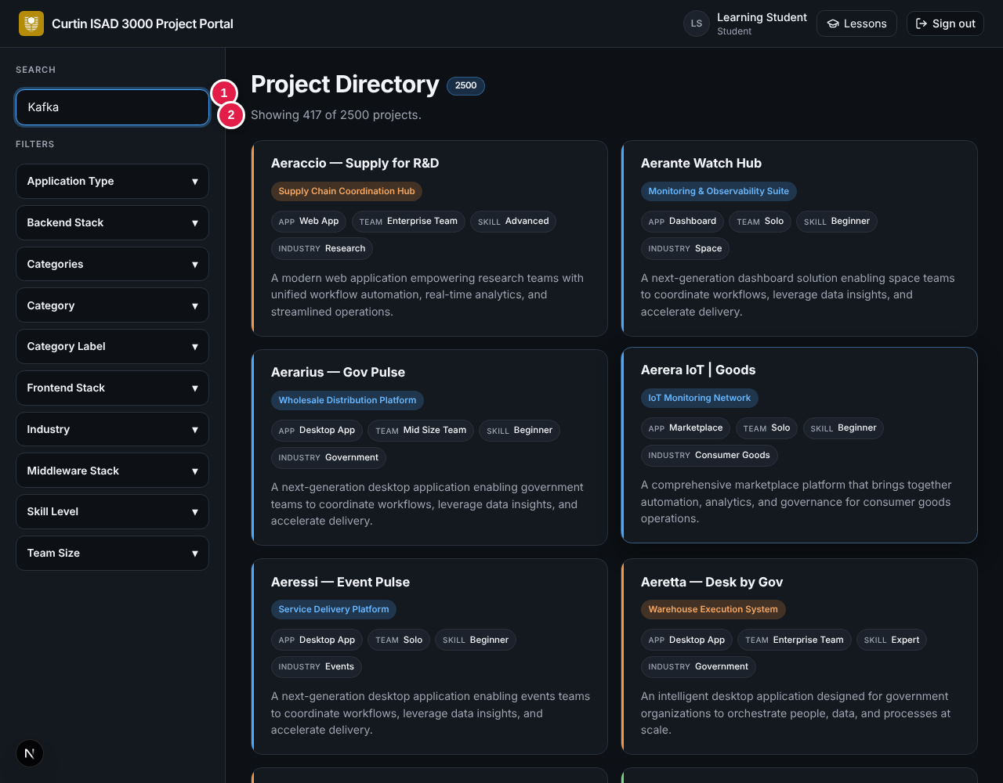
Searching for "Kafka": (1) search box, (2) result count
- Type words from the title, description, ID or technology. The list updates as you type.
- Not case sensitive. With several words, projects containing more of them appear first.
- The line under the title shows the result: "Showing 417 of 2500 projects." Delete the text to see everything again.
Try | You get
PRJ-0001 | That single project
Kafka | 417 projects that use Kafka
zzzz | "Showing 0 of 2500 projects" - try other words

5. Filters
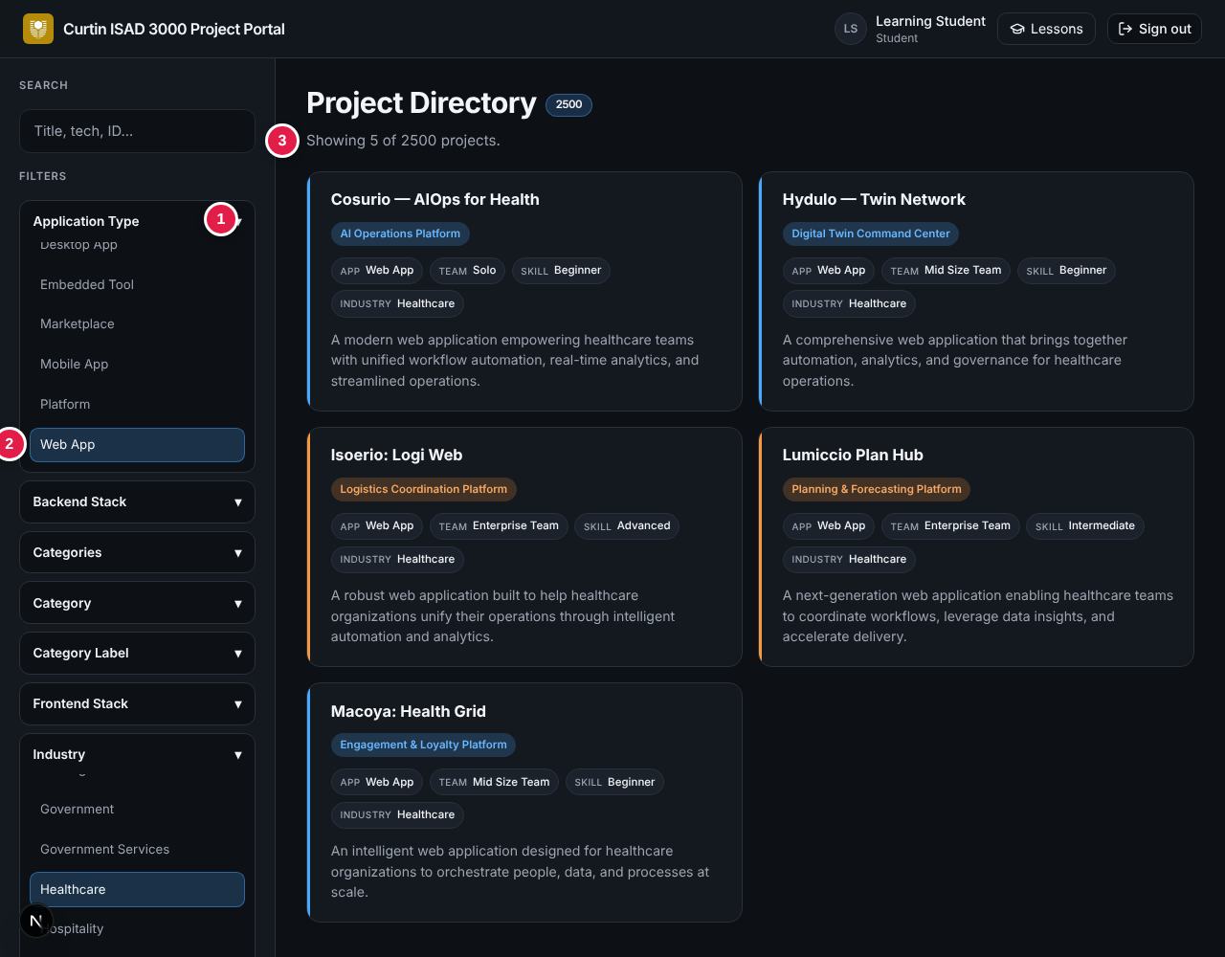
Filters: (1) open a group, (2) pick an option, (3) result count
- Click a group such as Application Type or Industry to open it.
- Click one option. It turns blue and the list narrows at once.
- Open another group to narrow further - all filters apply together. In the picture, Web App + Healthcare gives 5 projects.
- Click All in a group to remove its filter.
Group | Use it to...
Skill Level | Match difficulty: Beginner, Intermediate, Advanced, Expert.
Team Size | Solo, Mid Size Team or Enterprise Team.
Industry / Application Type | Pick a sector or the kind of app (Web, Mobile, API, Dashboard...).
Frontend / Backend / Middleware Stack | Find projects using technology you know.
WARNING
If you see "Showing 0 of ...", the filters cannot match together. Choose All in one group.

6. Project details
Click any card to open the full project.
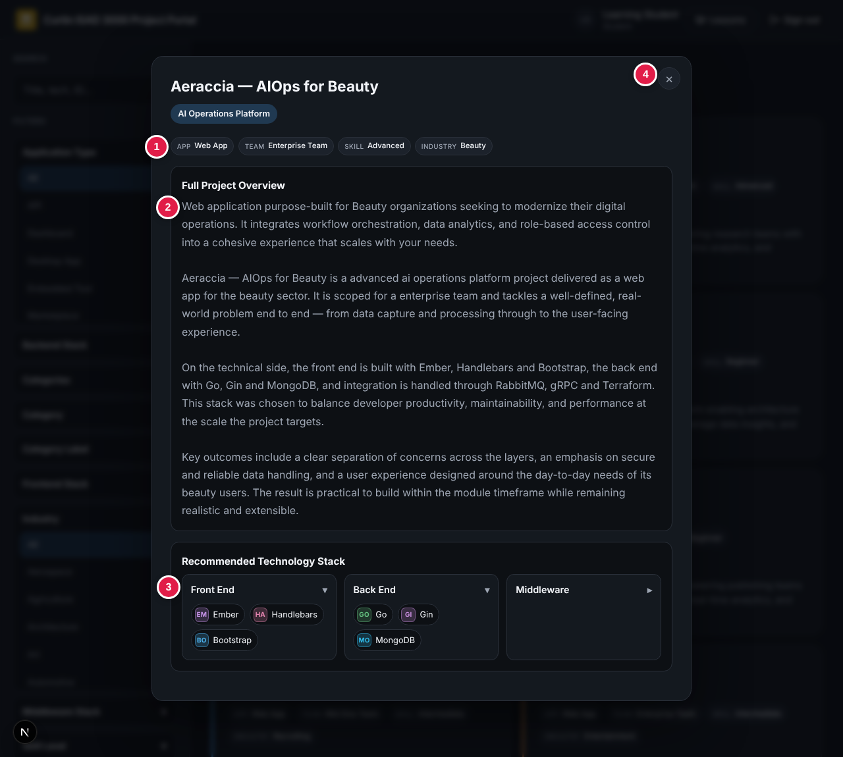
Project window: (1) labels, (2) overview, (3) technology stack, (4) close
- Overview explains the project, the sector and the expected outcomes.
- Technology stack has three sections - Front End, Back End, Middleware. Click one to open or close it.
- Close with the × or by clicking the dark area outside. You return to the same list.

7. Lessons & Videos
Click Lessons in the top bar (1 in the picture) to watch lecture videos and download lesson documents your lecturer has added.
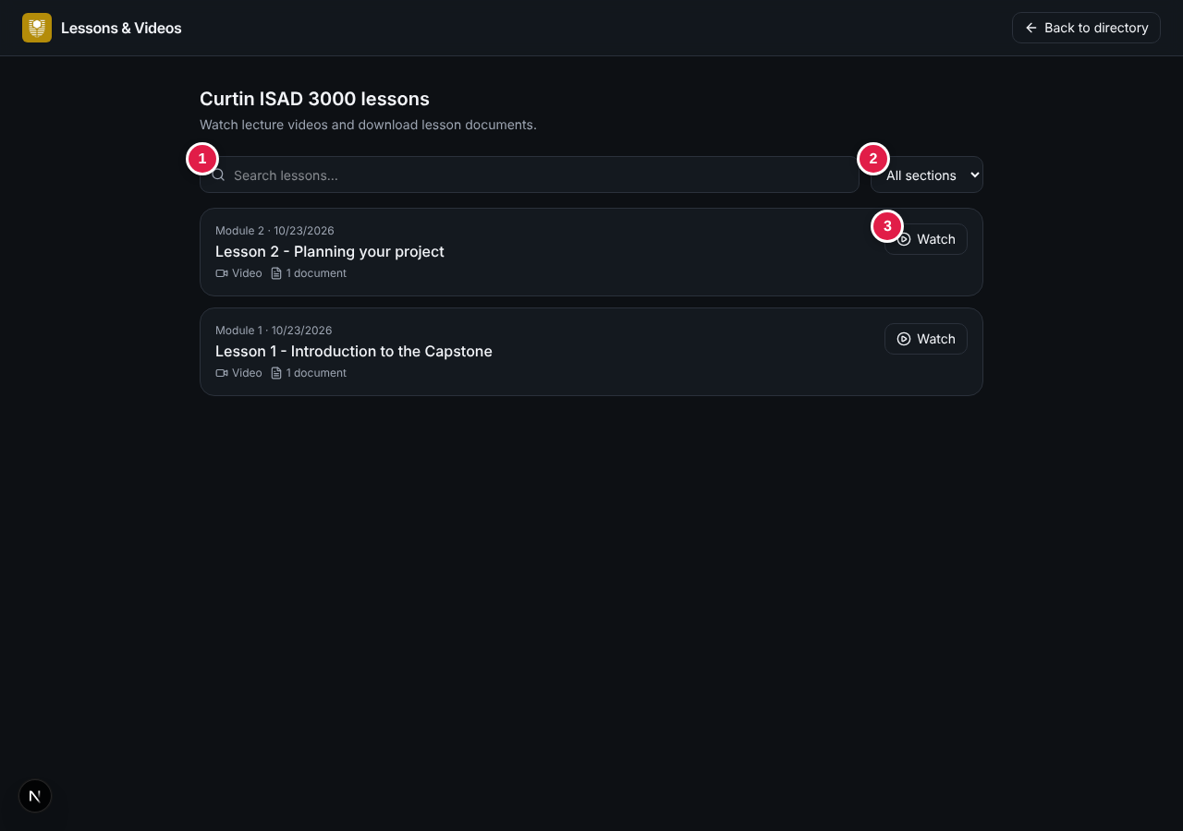
Lessons: (1) search, (2) section list, (3) Watch
- Type in Search lessons... or choose a section such as Module 1.
- Click Watch (or Open) on a lesson.
- Play the video. Uploaded videos have a progress bar you can drag; YouTube videos play in the YouTube player.
- Click Download to save a lesson document. Click Hide to close the lesson.
- Click Back to directory to return to the projects.
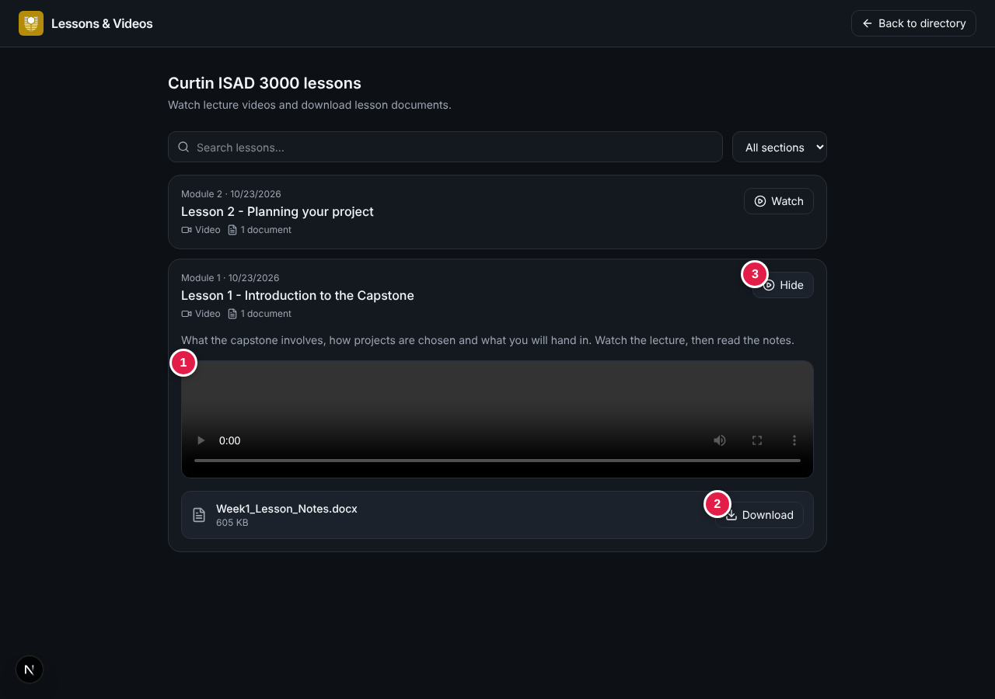
Open lesson: (1) video, (2) Download, (3) Hide
NOTE
No lessons yet? The page says so - your lecturer adds them. After the Portal is updated you may see a short maintenance notice: click Got it and it will not appear again.

8. For lecturers: add and delete lessons
Sign in with a Lecturer account (an approved email; see 2a). The Lessons page then shows Add lesson and a trash button on each lesson.
- On the Lessons page click Add lesson.
- Enter a title (required). Optionally add a section (for example Module 3) and a short description.
- Add at least one of: a YouTube link, a video file (.mp4 or .webm, up to 20 MB) or documents (up to 5; PDF, Word, PowerPoint, Excel, text, zip or images, 10 MB each).
- Click Save lesson. "Lesson added." appears and the lesson is listed first.
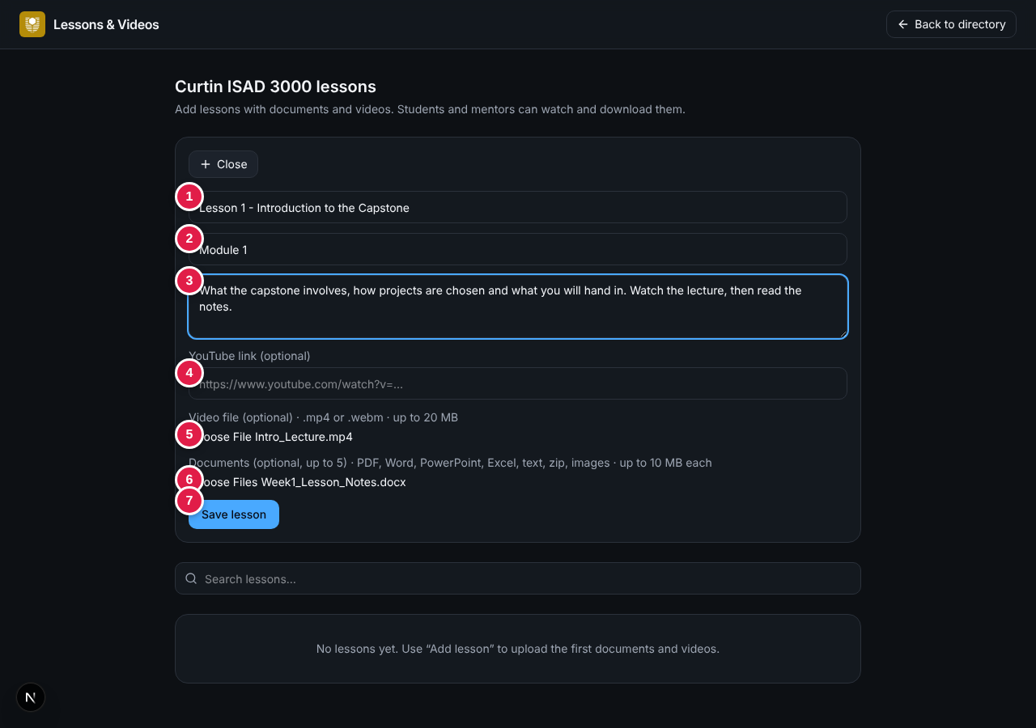
Add lesson: (1) title, (2) section, (3) description, (4) YouTube link, (5) video file, (6) documents, (7) Save lesson
Message | What it means
Add at least one document, video file or YouTube link. | The lesson needs content as well as a title.
That does not look like a YouTube link. | Paste the full video address from YouTube.
The video is larger than 20 MB... | Upload the video to YouTube and paste the link instead.
You can attach up to 5 documents per lesson. | Remove some documents.
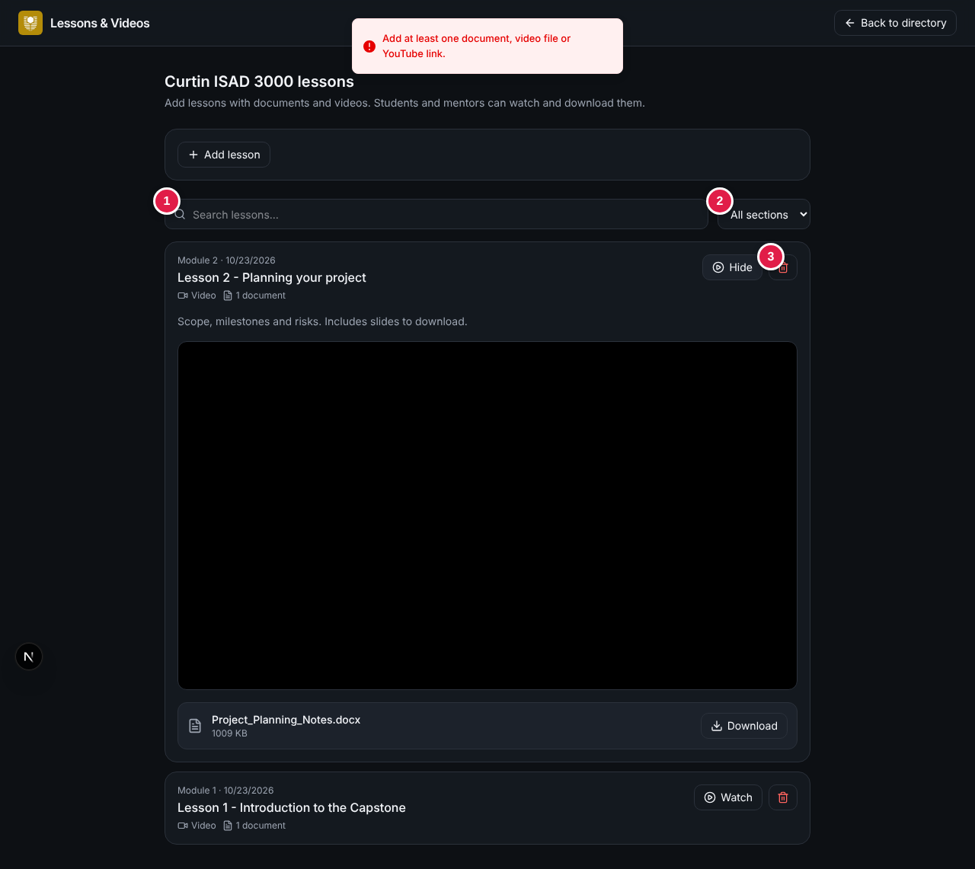
Lecturer view: (1) search, (2) section list, (3) delete
To remove a lesson click the trash button and confirm. The lesson and its files are deleted for everyone.

9. Sign out and quick help
Click Sign out (top right). You are also signed out after 8 hours. Always sign out on shared computers.
Problem | What to do
Back at the sign-in page | Your 8-hour session ended. Sign in again.
"Showing 0 of 2500" | Clear the search box and choose All in each filter group.
"Unable to load project data." | Refresh the page; if it persists, tell your lecturer.
No sign-in code arrives | Check spam and see the Login Guide.
"No account found for that email" | Use the Create account tab first.
"An account with this email already exists" | Use the Sign in tab.
"Account created as a student" | Your email is not approved as a lecturer yet. Ask the portal owner.
No Add lesson button | Your account is a Student account. Lecturers need an approved email.

